
Smart Code Review, Debugging and Optimization System

Project Description:
Smart Code Review, Debugging and Optimization System is an AI-powered platform designed to help developers improve code quality through automated code review, error detection, and optimization. The system utilizes the Groq API with the Llama 3.3 70B model to analyze source code and provide real-time feedback on bugs, performance issues, security vulnerabilities, and coding best practices.
The platform includes multiple intelligent modules such as Code Review, Error Debugging, Code Optimization, Complexity Analysis, and an AI Assistant Chatbot. It can identify coding issues, explain errors, suggest improvements, and automatically generate optimized versions of code. The system supports developers in writing clean, efficient, secure, and maintainable software by providing detailed insights and actionable recommendations.
The backend of the application is developed using FastAPI and PostgreSQL, while the frontend is built with HTML5, Tailwind CSS, and JavaScript to provide a responsive and user-friendly interface. Secure user authentication is implemented using JWT-based authentication, ensuring safe access and data protection.
By automating the software review and debugging process, the system significantly reduces manual effort, improves code maintainability, enhances developer productivity, and accelerates the software development lifecycle. The platform serves as a smart development assistant that helps programmers identify issues quickly, optimize code performance, and follow industry-standard coding practices, ultimately leading to the creation of high-quality and production-ready software applications.
_{Problem Statement:}
Traditional code review processes require significant manual effort and time. Developers often spend considerable time identifying bugs, fixing errors, optimizing performance, and ensuring coding standards compliance. Manual reviews may miss security vulnerabilities and performance bottlenecks, leading to reduced software quality. Therefore, an intelligent AI-powered system is required to automate code review, debugging, and optimization while providing real-time feedback and suggestions.
_{Objectives:}
- Automate code review and debugging processes.
- Detect bugs and security vulnerabilities.
- Improve code quality and maintainability.
- Generate optimized and production-ready code.
- _{Analyze algorithm complexity.}
- Reduce development and review time.
- Provide AI-powered learning assistance.

Scenario 1: Smart Code Review and Optimization for Developers:
The CodeRefine system helps developers improve code quality through AI-powered code analysis and optimization. Developers can upload source code in multiple programming languages and receive detailed feedback on bugs, performance bottlenecks, security vulnerabilities, and coding standard violations. The system also provides optimized and rewritten code with clear explanations. This reduces manual debugging effort, improves development speed, and helps developers create clean, efficient, and production-ready applications.
Scenario 2: AI-Assisted Learning Platform for Students:
CodeRefine can be used as an intelligent learning assistant for programming students. Students can submit their code and instantly receive explanations about errors, inefficient logic, and best coding practices. The AI-generated code improvements help learners understand how to write cleaner and more optimized programs. Features such as code correction, explanation generation, and language translation make the platform an effective tool for improving programming knowledge and problem-solving skills.
Scenario 3: Real-Time Code Analysis During Technical Interviews and Training:
Organizations and training institutes can use CodeRefine to evaluate coding assignments and programming exercises. The system automatically reviews submitted code, identifies issues, and provides detailed suggestions for improvement. Trainers and interviewers can assess coding quality more efficiently, while candidates receive instant feedback to enhance their solutions. This reduces evaluation time and ensures consistent assessment standards across multiple users.
Scenario 4: Enterprise Software Quality Assurance:
Software companies can integrate CodeRefine into their development workflow to maintain high coding standards across large-scale projects. The system continuously analyzes code for bugs, security risks, and performance issues while suggesting optimized solutions. By automating code review and refactoring tasks, organizations can reduce post-deployment defects, improve maintainability, and accelerate software delivery. This enhances overall software quality and increases development team productivity.
Scenario 5: AI-Powered Documentation and Prompt Generation:
CodeRefine can assist developers by automatically generating project documentation, code explanations, and optimized prompts for AI applications. This feature helps teams maintain proper project records, improve collaboration, and reduce documentation effort. Developers can quickly understand complex codebases and create structured documentation for project maintenance and future development.

Traditional Code Review Process:

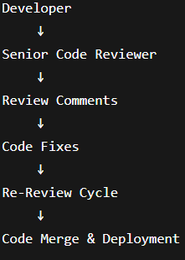
AI-Powered Code Review Process:

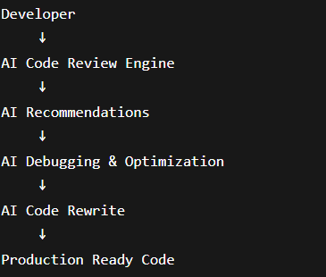

Who Can Use This Project?
The Smart Code Review, Debugging and Optimization System is designed for a wide range of users involved in software development and programming activities. The system provides intelligent code analysis, automated debugging, optimization suggestions, and code quality improvements, making it beneficial for both beginners and experienced developers.
1. Students and Beginners:
Students who are learning programming can use the system to identify coding mistakes, understand errors, and learn best coding practices. The AI-generated explanations help them improve their programming skills and coding confidence.
2. Software Developers:
Professional developers can utilize the system to perform quick code reviews, detect bugs, improve code quality, and optimize application performance. This reduces manual effort and speeds up the development process.
3. Development Teams:
Software development teams can use the platform to maintain coding standards, ensure code consistency, and reduce the workload of manual peer reviews. The system helps teams deliver high-quality software faster.
4. Technical Interview Candidates :
Candidates preparing for coding interviews can use the platform to analyze solutions, understand algorithm complexity, optimize code, and improve problem-solving approaches.
5. Freelancers and Independent Developers:
Freelancers can leverage the system as a personal code review assistant to improve project quality before delivering solutions to clients.
6. Educational Institutions:
Colleges, universities, and training institutes can use the system as a learning and evaluation tool for programming assignments and coding exercises

System Architecure:
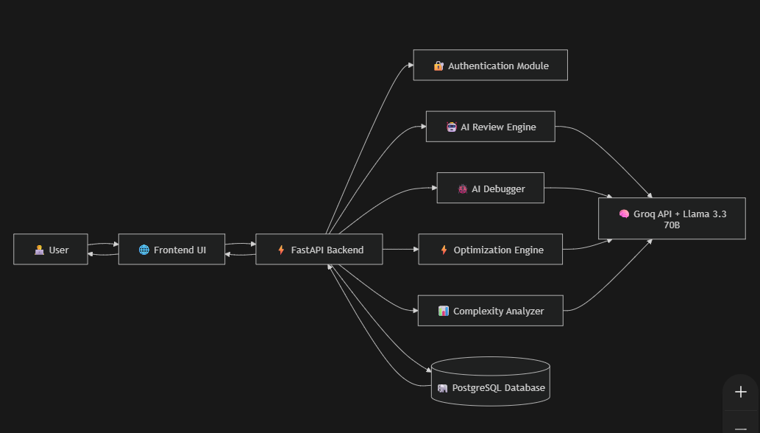

Project Workflow:
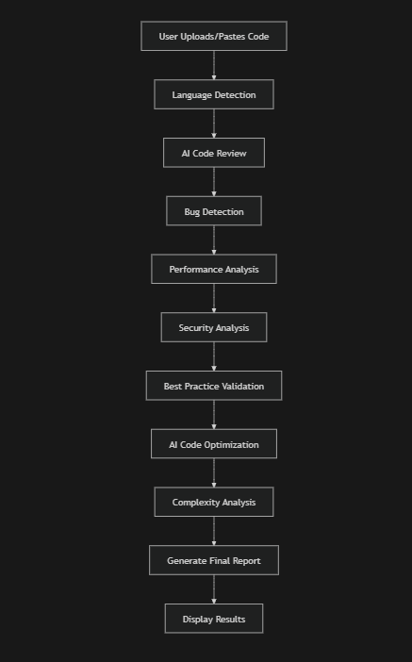
Advantages of Proposed System:
- Real-time AI-powered code review.
- Faster bug detection and debugging.
- Improved software quality.
- Reduced manual review effort.
- Enhanced developer productivity.
- Security vulnerability detection.
- Automatic code optimization and refactoring.
- Beginner-friendly explanations through AI assistance.

● Users input their source code and select a programming language, which is
sent to the backend powered by Groq’s Llama 3.3 70B model for real-time
analysis.
● The system scans the code to detect bugs, security flaws, performance
issues, and best practice violations, classifying them by severity (Critical,
High, Medium, Low).
● AI generates detailed, line-by-line improvement suggestions and provides
instant feedback for better understanding and quick resolution.
● Users can initiate the Rewrite Function to automatically refactor and optimize
the code, producing clean, well-documented, and production-ready output.
● Built with FastAPI, HTML5, Tailwind CSS, and JavaScript, the platform enables
real-time code review with side-by-side comparison, clear explanations, one-click
export, and enhanced readability through Marked.js and Highlight.js.
To accomplish this, we have to complete all the activities listed below,
● Model Initialization:
○ Generate Groq API key
○ Initialize the pre-trained Llama 3.3 70B model
● Application Development:
○ Build backend APIs using FastAPI and connect with Groq for real-time
inference.
○ Design an interactive frontend using HTML5, Tailwind CSS, and JavaScript
integrated with Marked.js and Highlight.js

● Deployment:
○ Host the application for live code review and rewriting.
○ Optimize performance for fast, seamless AI-driven processing.

Technology | Purpose
Python | Backend Development
FastAPI | REST API Framework
Groq API | AI Model Access
Llama 3.3 70B | Code Analysis
PostgreSQL | Database
JWT | Authentication
HTML5 | Frontend Structure
Tailwind CSS | UI Styling
JavaScript | Interactivity
Marked.js | Markdown Rendering
Highlight.js | Syntax Highlighting

Prior Knowledge:
You must have prior knowledge of the following topics to complete this project.
• LLM & Groq API:
A large language model (LLM) is an advanced AI system that uses deep neural networks
with billions of parameters to analyze, understand, and generate human-like code or
text. In this project, the Llama 3.3 70B model integrated with the Groq API enables
ultra-fast inference for real-time code review and rewriting. Understanding how LLMs
perform tasks such as code generation, refactoring, and semantic analysis is essenti al.
Examples of such models include ChatGPT by OpenAI, Claude by Anthropic, and Gemini
by Google.

https://groq.com/
https://www.llama.com/
• FastAPI:
Knowledge of building high-performance web backends using FastAPI, modern Pythonframework used for developing RESTful APIs. Understanding how to create endpoints,handle requests, and integrate AI models with APIs is important.
https://fastapi.tiangolo.com
• Frontend Development (HTML5, Tailwind CSS, JavaScript):
Familiarity with creating responsive, interactive web interfaces using HTML5, Tailwind
CSS, and Vanilla JavaScript. Understanding how to structure layouts, style components,
and manage user interactions is required.
https://tailwindcss.com
• Code Rendering Libraries:
Basic knowledge of Marked.js and Highlight.js for rendering markdown contentand
syntax highlighting within the web interface. These libraries are used to display
reviewed and rewritten code in a structured and visually clear manner.
https://marked.js.org
https://highlightjs.org
Project Structure:
Create the Project folder which contains application file as shown below
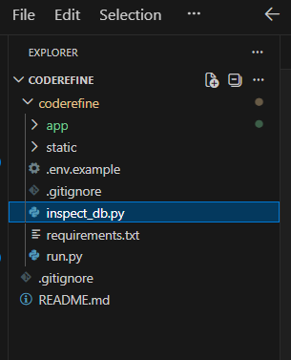
Database Design:
The system uses PostgreSQL to store user information, authentication details, review history, and session data.
Tables Used:
- Users
  - User ID
  - Username
  - Email
  - Password Hash
- Review History
  - Review ID
  - User ID
  - Input Code
  - Review Result
  - Timestamp
- Sessions
  - Session ID
  - User ID
  - JWT Token
- Audit Logs
  - Activity Tracking
  - Login History
  - Review Activity

Milestone 1: Requirements Specification:
Specifying the required libraries in the requirements.txt file ensures a smooth setup and
reproducibility of the project environment. This makes it easier for others to copy the
development environment.
Activity 1: Create a requirements.txt file to list the required libraries:
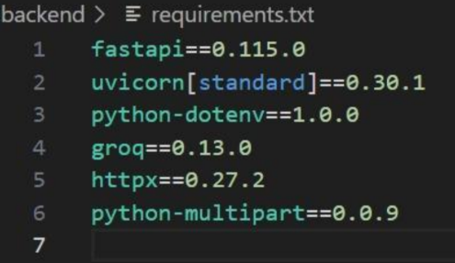
Activity 2: Install the required libraries.

Milestone 2: Initializing the Model:
For initializing the model we need to generate GROQ API.

Activity 1: Generate GROQ API:

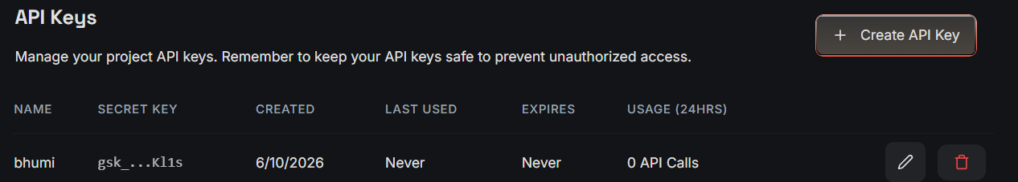

Activity 2.1: Import necessary files:
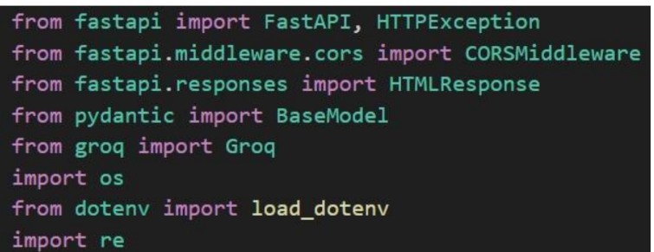
● FastAPI is used to build high-performance backend APIs that manage code
submission, analysis, and rewriting requests while enabling seamless
communication between the frontend and the Groq-powered LLM for real-time
● Provides ultra-fast LLM inference using the Llama 3.3 70B model to analyze,
review, and rewrite code instantly.
Activity 2.2: Configuration of the GROQ API:
Configuring the API key:
The configure function is used to set up or configure the GROQ API with an
API key. The provided API key, in this case, is " and it should be placed in “.env” file
Milestone 3: Interfacing with Pre-trained Model:
In this milestone, we will build a prompt template to generate feedback based on
the project details entered by the user.

Activity 1: Create a function to review response:
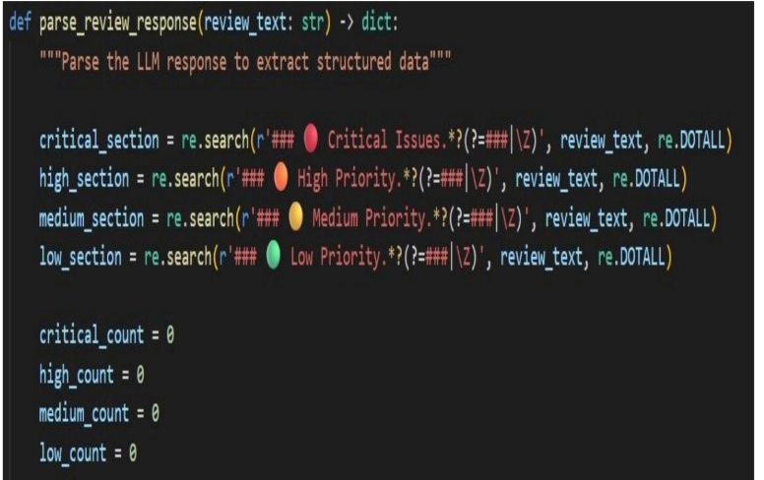
● The parse_review_response function is designed to extract and categorize
feedback from an LLM-generated review text based on priority levels.
● The function accepts a review_text string as input and searches for
sections labeled as Critical Issues, High Priority, Medium Priority, and
Low Priority using regular expression patterns.
● It initializes counters for each priority category and attempts to identify
and separate these sections within the review text for structured
analysis.
● The function is useful for converting unstructured LLM output into
structured data, making it easier to quantify and further process review
feedback.
Activity 2: Create a function to review code:
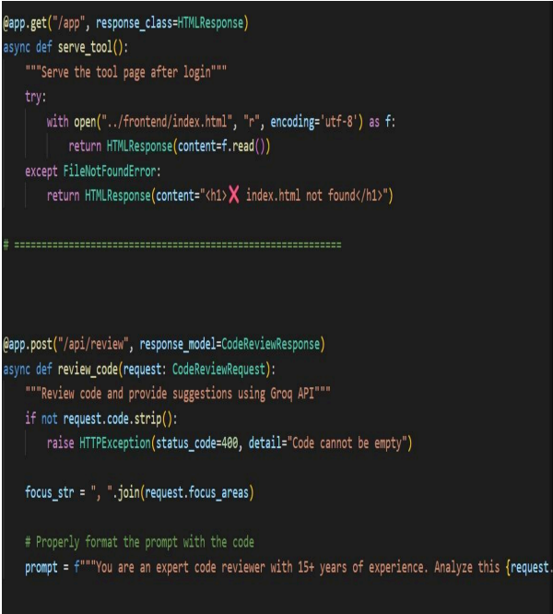
● The serve_tool function serves the main tool page (index.html) after user login,
returning the page content or an error message if the file is not found.
● The review_code function handles code review requests from the frontend and
provides suggestions using the Groq API.
● It validates that the code input is not empty, raising an HTTPException if it is.
● The function formats the focus areas provided by the user, builds a prompt for the
AI reviewer, and sends the request for review.
● The response is returned in the specified model format, making it suitable for
structured API communication.
Milestone 4: Model Deployment:
In this milestone, we are deploying the intelligent code review and rewrite model using
FastAPI. The web interface visible in the image is built on FastAPI, providing a
responsive and interactive platform where users can submit code, choose the
programming language and focus areas, and receive structured review results directly in
their browser. FastAPI enables efficient backend handling and smooth integration of the
code review model into a web-based application, ensuring real-time analysis and
recommendations for users.
Activity 1: Give the project title, display the image and the character and input Information:
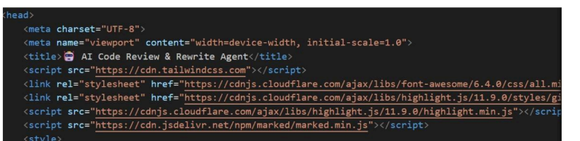
The web application sets the title to "AI Code Review & Rewrite Agent," which is
clearly displayed at the top of the browser tab, helping users instantly understand the
main purpose of the tool.
∙ A visually engaging robot emoji is placed next to the title, providing a friendly and
welcoming impression for users interacting with the code review agent.
∙ The app uses multiple external style and script libraries, such as Tailwind CSS for
modern UI design and Font Awesome for iconography, which enhance the application’s
look and user experience.
∙ Highlight.js and Marked.js are integrated to support syntax highlighting and formatted
markdown rendering, ensuring that reviewed code and feedback are displayed in a
readable and attractive format.
∙ Meta tags and responsive viewport settings in the HTML head ensure the web interface
adapts seamlessly to different device sizes, offering a polished and user-friendly
experience across all platforms.
Activity 2: Run the web application
● Open the terminal from the vs code
● Navigate to the folder where your Python script is.
● Now type “python main.py” command
● Navigate to the localhost where you can view your web page
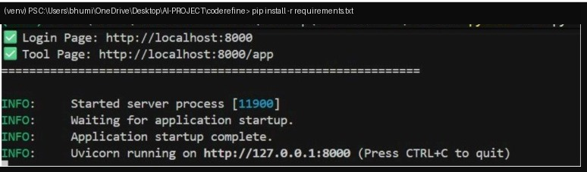
Activity 3: Output:
Now, the application will open in the web browser

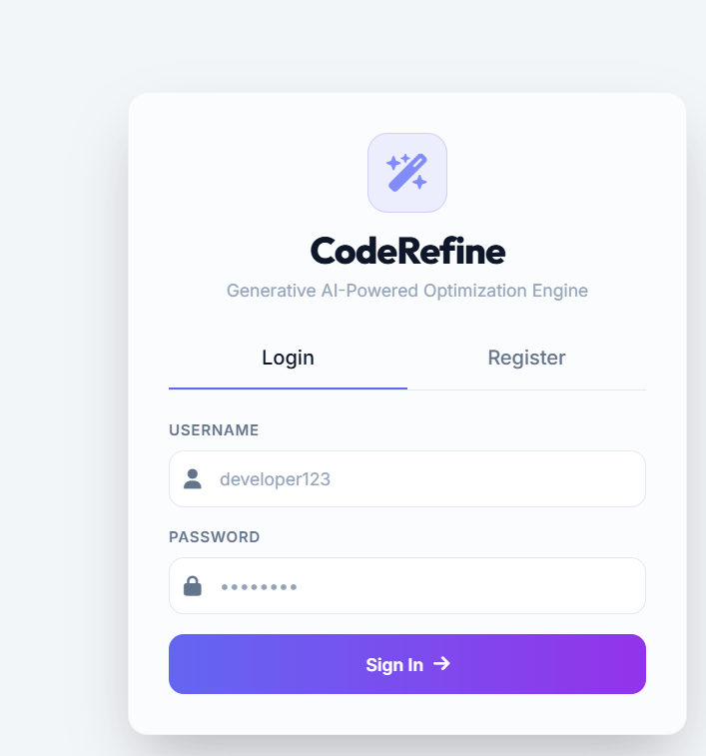
Security Features:
- JWT-Based Authentication
- Password Hashing using Bcrypt
- Protected API Endpoints
- Environment Variable Protection
- Secure Database Access
- Input Validation using Pydantic
- Prevention of Unauthorized Access

This is the login page of CodeRefine. It provides secure user authentication using a username and password. Existing users can log in, while new users can register through the Register tab. After successful authentication, users gain access to the AI-powered code review, optimization, debugging, and complexity analysis features available within the platform
CODE REVIEW SECTION:

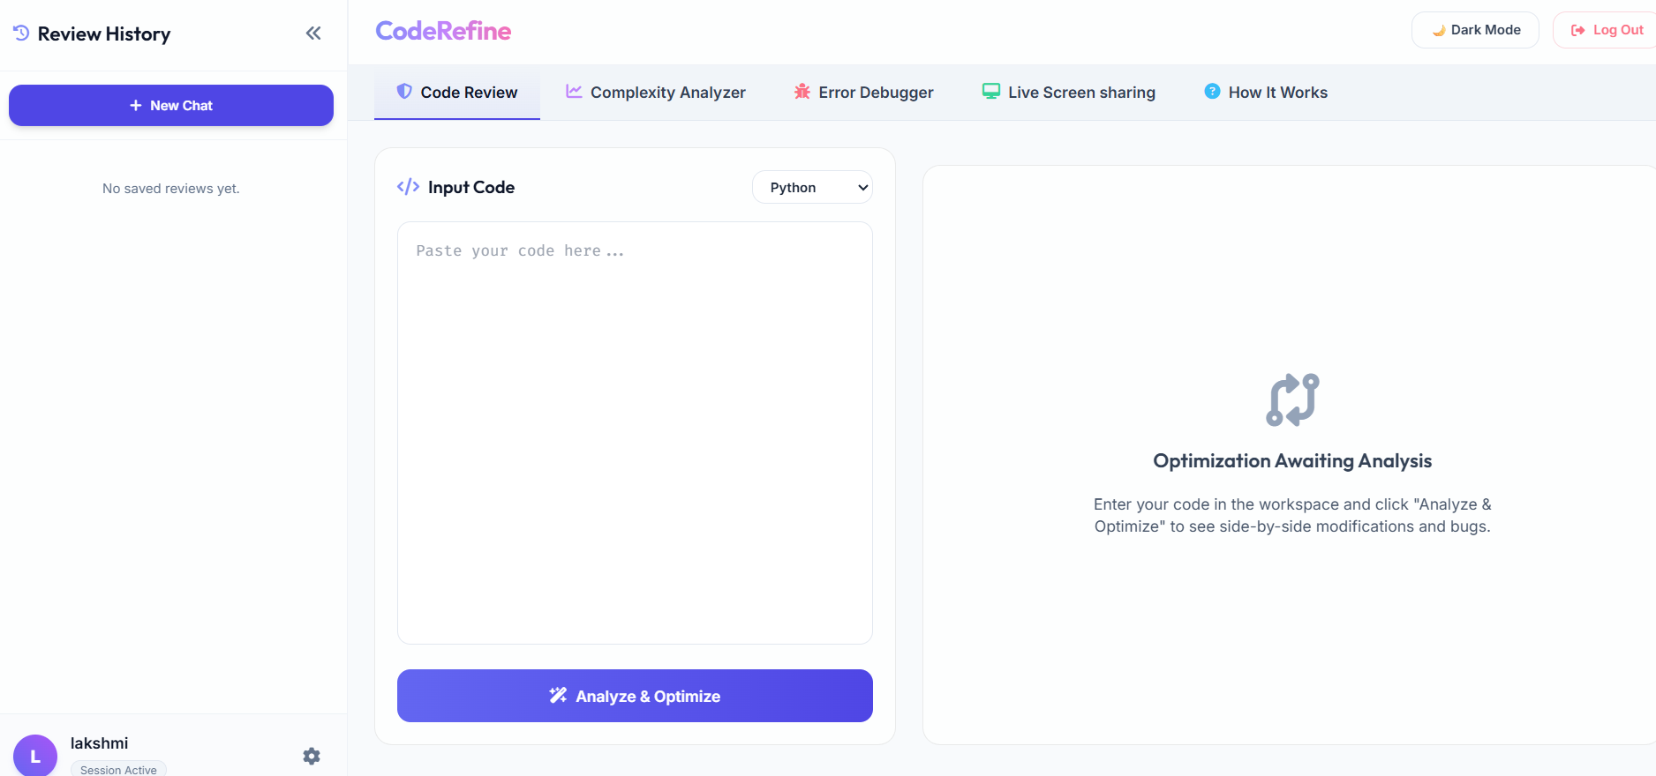
After giving the input of functionality, the output is:

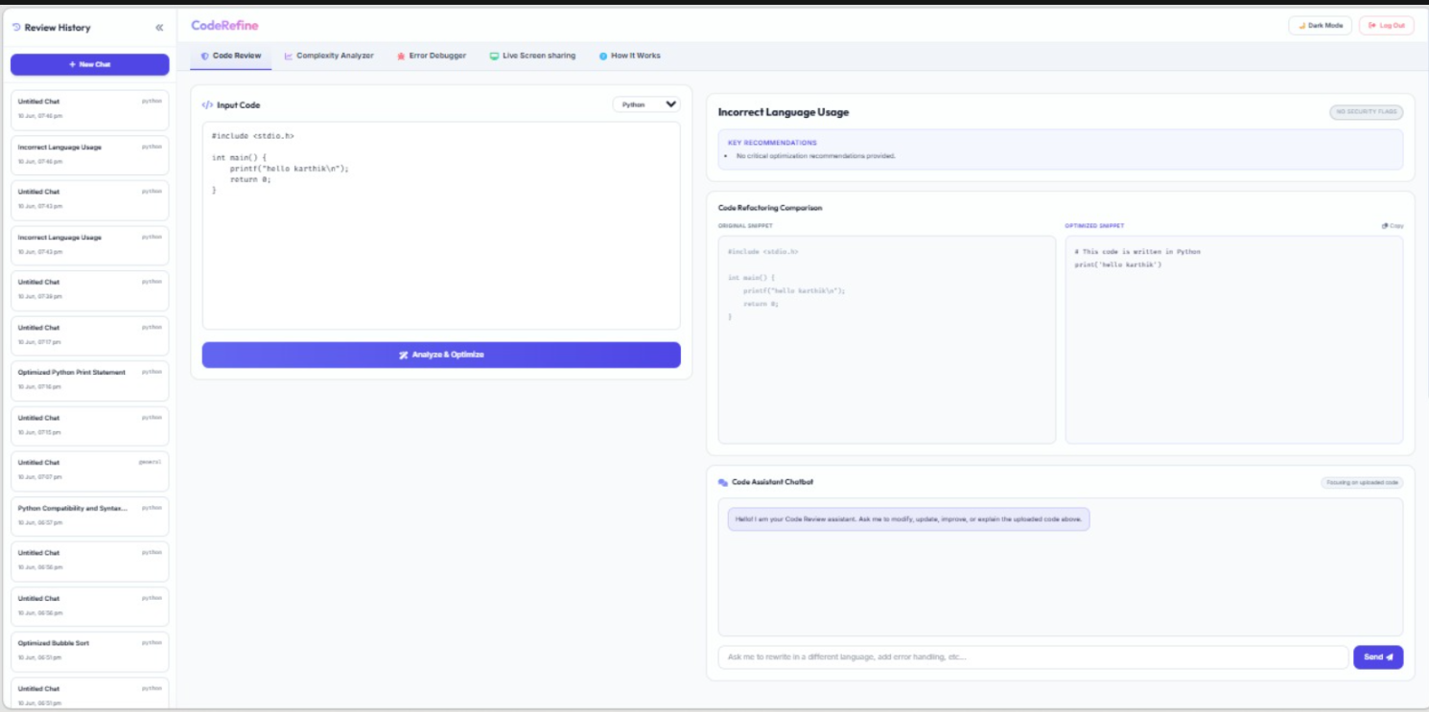

This is the Code Review module of CodeRefine. Users can submit source code and select the programming language. The AI analyzes the code, identifies issues, suggests improvements, and generates an optimized version. The original and optimized code are displayed side-by-side for comparison. Additionally, an AI chatbot is available to answer questions, explain code, and provide further optimization recommendations. All analyses are saved in the review history for future access
COMPLEXITY ANALYZER SECTION:

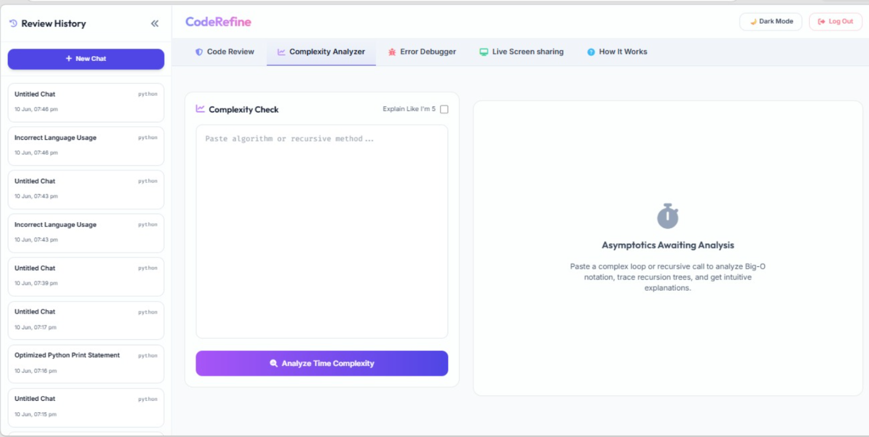
After giving the input of functionality, the output is:
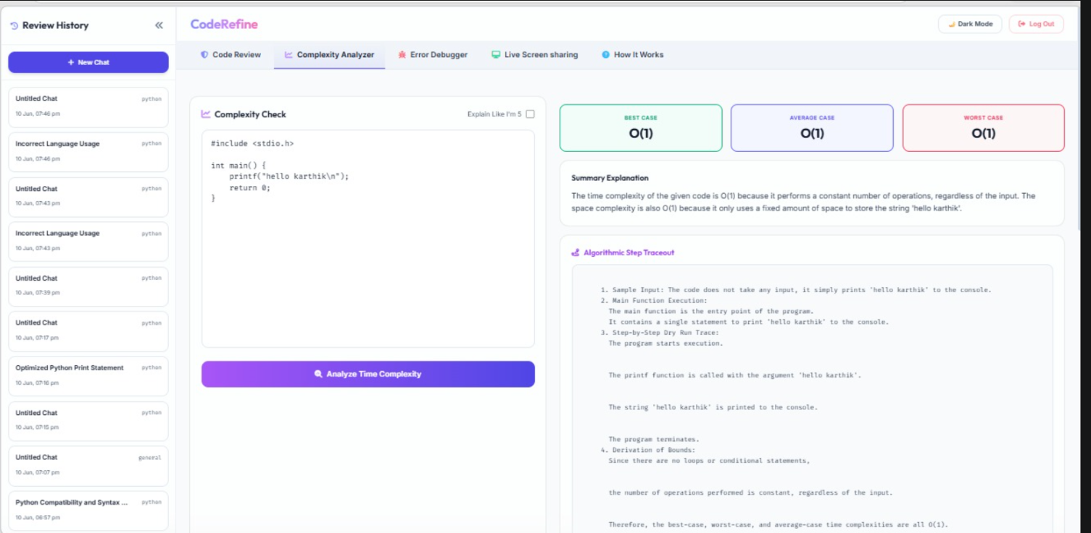
This is the Complexity Analyzer module of CodeRefine. Users can submit source code, and the AI automatically calculates the Best Case, Average Case, and Worst Case time complexities. The system also generates a summary explanation and a detailed step-by-step execution trace showing how the complexity was derived. Additionally, the ELI5 option provides beginner-friendly explanations, making algorithm analysis easier for students and developers.
ERROR DEBUGER SECTION:
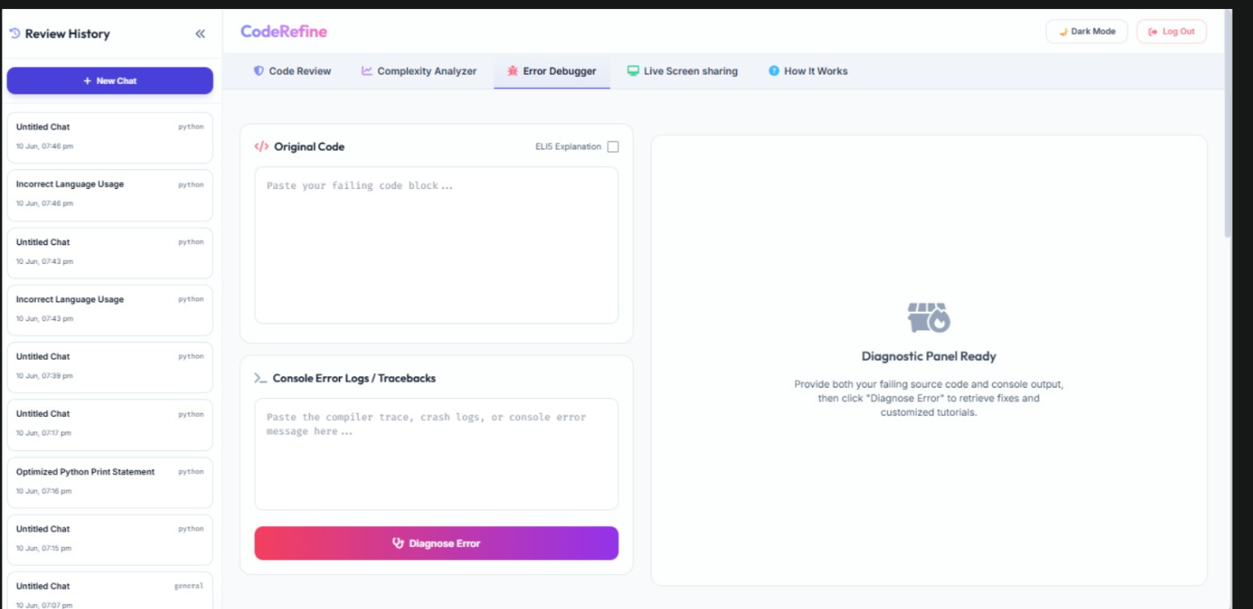
After giving the input of functionality, the output is:
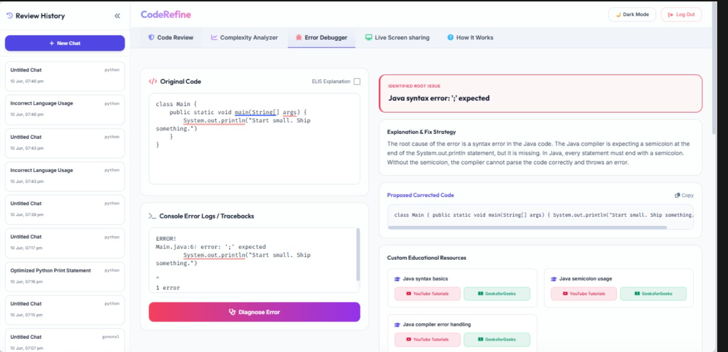
This is the Error Debugger module of CodeRefine. Users provide their source code along with compiler errors or runtime logs. The AI analyzes both inputs, identifies the root cause of the problem, explains why the error occurred, and generates a corrected version of the code. Additionally, the system provides educational resources to help users understand the concept behind the error and improve their programming skills. This significantly reduces debugging time and helps developers resolve issues more efficiently.
LIVE SCREEN SHARING SECTION:

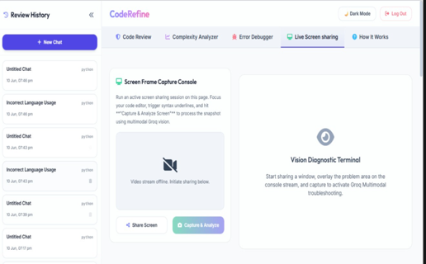

After giving the input of functionality, the output is:
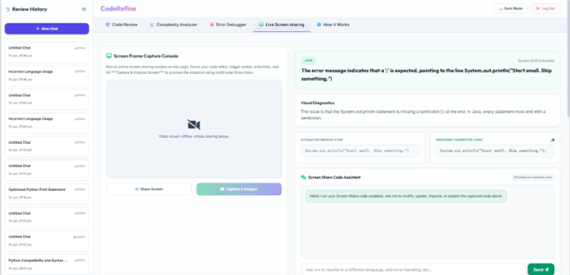

This is the Live Screen Sharing module of CodeRefine. Instead of manually copying code and errors, users can share their screen and capture a snapshot of their coding environment. The AI uses OCR technology to extract code and error messages directly from the screen, analyzes the issue, identifies the root cause, and generates a corrected solution. An integrated AI assistant is also available to explain errors and provide additional recommendations. This feature enables faster and more convenient debugging through visual analysis.
HOW IT WORKS:
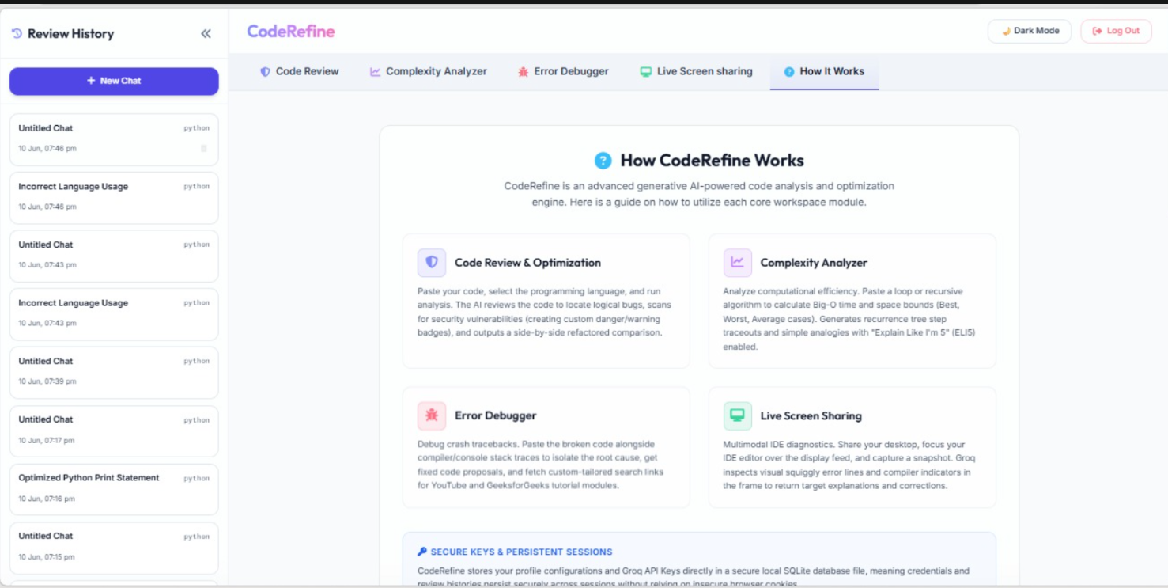 This page provides an overview of how CodeRefine works. It explains the four core modules of the system: Code Review & Optimization, Complexity Analyzer, Error Debugger, and Live Screen Sharing. Each module uses AI to assist developers in analyzing, optimizing, debugging, and understanding code. The platform also supports secure key management and persistent session storage, ensuring that user data and analysis history remain available across multiple sessions. This section helps new users quickly understand the functionality and workflow of the entire application..
Future Enhancements:
- GitHub Repository Analysis
- Multi-file Code Review
- Team Collaboration Features
- PDF Report Generation
- CI/CD Integration
- AI-Powered Test Case Generation
- Voice-Based AI Assistant
- VS Code Extension Integration
- Cloud-Based Collaboration Workspace

CONCLUSION :
The Code Review and Rewriting System offers a complete AI-powered solution for improving code quality, maintainability, and security across different programming languages. It combines Groq’s ultra-fast LLM inference with a FastAPI backend and a responsive Tailwind-based frontend. The system provides real-time, smart insights that go beyond traditional static analysis. It identifies problems related to bugs, performance, and security. It also rewrites the code with clear explanations and best-practice implementations. With detailed suggestions, severity categorization, and one-click copy for optimized code, this project connects AI-driven code review and intelligent code generation. It gives developers a faster, smarter, and more effective way to create clean, production-ready software
References:
- Groq API Documentation - https://groq.com
- Llama Documentation - https://www.llama.com
- FastAPI Documentation - https://fastapi.tiangolo.com
- PostgreSQL Documentation - https://www.postgresql.org
- Tailwind CSS Documentation - https://tailwindcss.com
- Marked.js Documentation - https://marked.js.org
- Highlight.js Documentation - https://highlightjs.org

GITHUB LINKS:
https://github.com/katurikeerthi123-sys/coderefine/tree/main/app
https://github.com/bhumi-1997/Smart-Code-Review-Debugging-and-Optimization-System
DEPLOYMENT LINK:
https://coderefine-zggu.onrender.com/

